**INTRODUCTION**

The IOT model that I have designed is the development of a password protected door lock system. With this enhancement to the user’s door, can ultimately benefit the user being way ahead of a step in terms of security. The system is basically to input a unique code to gain access to a door which is known only to the user. In the case of a false attempt, the sensors used in this model will detect an unauthorized attempt and be notified to the user immediately .In case of having very sensitive or classified files or information, this measure can be really a choice never to be regretted .In comparison with the traditional form of the use of keys, in comparison this method can be in much favoration , since it cannot be lock picked, key cut shaped neither be able to gain access without the knowledge of the owner.

Key aspect of the IOT Model

**Sensors used**

PIR Sensor - Detects that the user has been in the location as at the stated time.

● Ultrasonic Sensor - Detects the user’s distance towards the door.

**Actuators used**

Buzzer - Used to produce sounds when typing passwords and if it is incorrect.

● Transistor - Helps to amplify electronic signals and power.

● Resistor - Helps in reducing current flows and adjusting signal levels.

Connectivity of the model uses an Arduino Uno board along with a breadboard to help connect the elements of the model. Since Arduino doesn’t have built-in wifi , that will also be used to connect onto the user’s smartphone using the blynk application.

Data Analysis helps discover useful and valid information, in this case we could input the user’s required information to help store data in order to gain access upon verification. The door passwords and how many times it is used to access and open and details can be stored and interpreted as well.

This can help the owner make good decisions that will be for the betterment .Communication method linked can help make the system more effective.

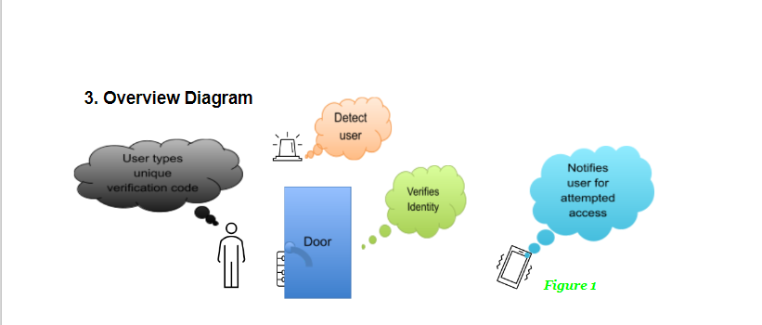

**Model Implementation**

The above simulation basically explains the process of the user entering the apartment and is in the process of unlocking the door, meanwhile the motion sensor detecting his presence. Now instead of the traditional form of using a key lock and opening, he will be inputting the unique digit code which is only known to him. Upon successful code verification it would unlock the door and welcome him. After he physically pushes the door open, it would scan for his usual temperature through sensors .With a false attempt, the one standing in front of the door will be proven unauthorized and following the siren ring connected to the motion sensor, the user’s phone will be alerted that an unauthorized access is attempted at the doorstep

**Future Development**

The current art fact includes only one main door applied to a phone. Hopefully with further testing and verification with this use along with convincing feedback, several doors are being planned to be put on with different passwords connected to a single phone of the user .This method can be very useful in cases of installing the system to an organization, as the person trying to gain access has to go through several doors and passwords .There is also planning on this enhancement where when a false password is attempted thrice and proven unauthorized, the authorities or police are directly contacted by the system. This measure can be useful if the user is in a very far distance or even another country and will not be able to reach the door to investigate in time . Additionally there are ongoing procedures to implement voice and biometric scanners along to the keypad so that there’s more enhanced verification for user confirmation.

**Conclusion**

The current concept seems to be in perception of an enhanced system up to the communal standards preferred which indefinitely would help grow in terms of personal and capitalized development to the project and the needs of the end user’s requirement and satisfies the terms in the end .The current performance in the end is judged by the decision making of the forth coming and upgrades persisted to be used and managed, and for how well it can be managed can enable a well traced employability frequency .Concluding to this project being an IDE interface helps many consumers in the growing economy and inflation and to cope up with the level of referencing towards i.t